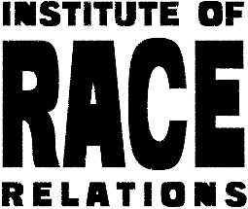
Application form
Communications officer at IRR

Please expand the boxes as required for your answers.

PERSONAL DETAILS

Name
Address
Email
Phone number

EDUCATIONAL QUALIFICATIONS
Date | Qualification

TRAINING AND OTHER RELEVANT EXPERIENCE (formal or informal)

Date

VOLUNTARY OR COMMUNITY ACTIVITY RELEVANT TO THIS POST
Date

EMPLOYMENT HISTORY

Date

PERSONAL SPECIFICATION - set out in detail with concrete examples how you meet the required essential and desirable skills and what you feel you as a person could bring to this post and to the IRR in general (up to 1,000 words)
Feel free to send us any links/attachments to your relevant work.

REFERENCES
Please supply two references with full contact details and indicate if you are happy for us to approach them before any job offer.
Referee 1

Referee 2

START DATE - please indicate when you could start work

Please email this completed form to info@irr.org.uk marked ‘Job application’ in the subject area by 5pm on 7 February 2020.

The completed monitoring form should be sent to jenny@irr.org.uk marked ‘job application’ in the subject area.

