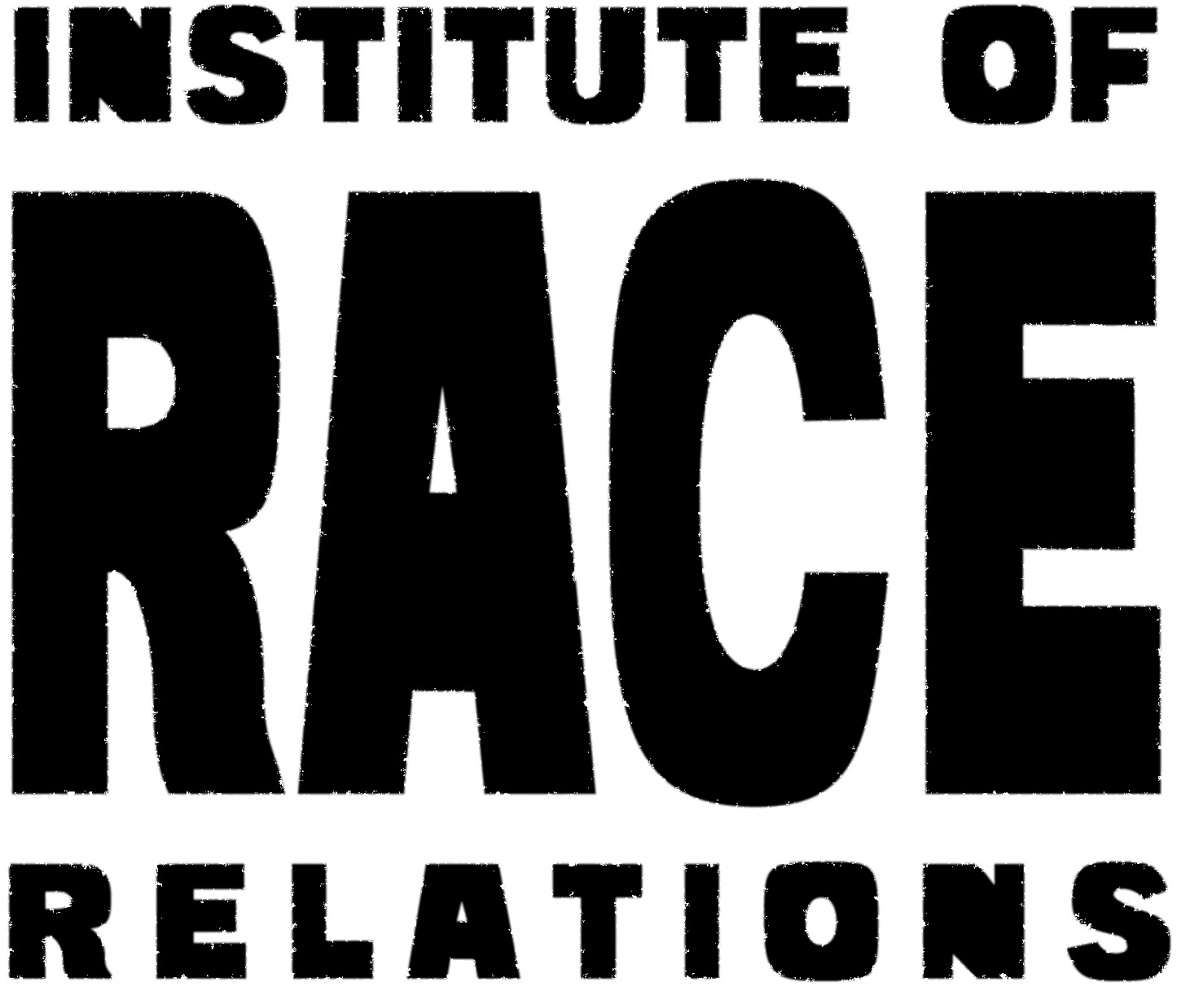

Equality and diversity monitoring form

The Institute of Race Relations wants to meet the aims and commitments set out in its equality policy. This includes not discriminating under the Equality Act 2010, and building an accurate picture of the make-up of the workforce in encouraging equality and diversity.

The organisation needs your help and co-operation to enable it to do this, but filling in this form is voluntary.

The information you provide will stay confidential, and be stored securely.

Please email the form to jenny@irr.org.uk

PLEASE DELETE AS APPROPRIATE

Gender | Male | Female | Prefer not to say

Age | 16-24 | 25-29 | 30-34 | 35-39 | 40-44 | 45-49
 | 50-54 | 55-59 | 60-64 | 65+ | Prefer not to say

What is your ethnicity?

Ethnic origin is not about nationality, place of birth or citizenship. It is about the group to which you perceive you belong. Please delete as appropriate

White | English | Welsh | Scottish | Northern Irish
 | Irish | British | Gypsy or Irish Traveller | Prefer not to say
 | Any other white background, please write in:
Mixed/multiple ethnic groups | White and Black Caribbean | White and Black African | White and Asian | Prefer not to say
 | Any other mixed background, please write in:
Asian/Asian British | Indian | Pakistani | Bangladeshi | Chinese
 | Prefer not to say | Any other Asian background, please write in:
Black/ African/ Caribbean/ Black British | African | Caribbean | Prefer not to say
 | Any other Black/African/Caribbean background, please write in:
Other ethnic group | Arab | Prefer not to say | Any other ethnic group, please write in:

Do you consider yourself to have a disability or health condition?
Yes | No | Prefer not to say

What is the effect or impact of your disability or health condition on your ability to give your best at work? Please write in here:

The information in this form is for monitoring purposes only. If you believe you need a ‘reasonable adjustment’, then please discuss this with your manager, or the manager running the recruitment process if you are a job applicant.

What is your religion or belief?
No religion or belief | Buddhist | Christian | Hindu
Jewish | Muslim | Sikh | Prefer not to say
If other religion or belief, please write in:

What is your sexual orientation?
Heterosexual | Gay woman/lesbian | Gay man | Bisexual
Prefer not to say | If other, please write in:

