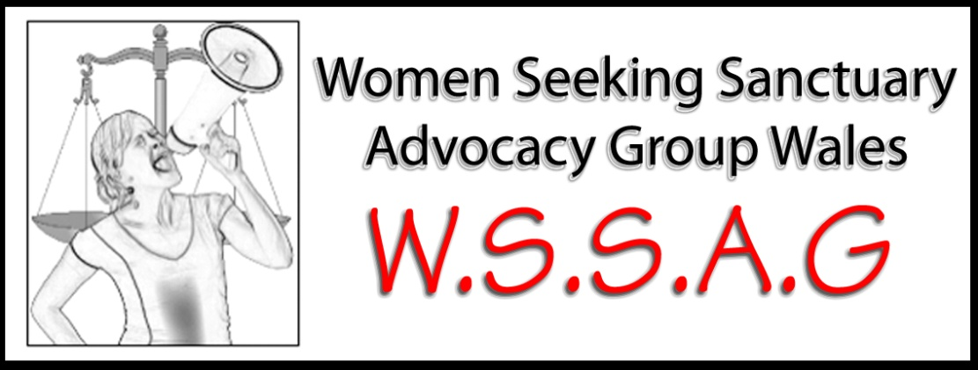
Free legal workshop
For PROFESSIONALS AND asylum-seeking women

by Rights of Women: http://www.row.org.uk

10.30-2.30pm Thursday 9th January 2014
Asylum refusal, advice on financial support and more

(With short question and answer session at the end)

Venue: 3 North Church Street, Butetown, Cardiff, CF10 5HB

Please contact wssagwales@yahoo.co.uk or call 07902562111 to book a place

